[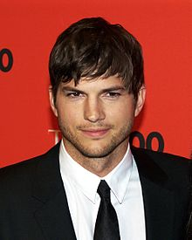](http://en.wikipedia.org/wiki/File:Ashton_Kutcher_by_David_Shankbone.jpg)[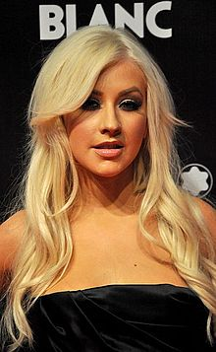](http://en.wikipedia.org/wiki/File:CA2010PREIMRE.jpg)[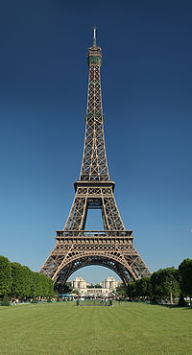](http://en.wikipedia.org/wiki/File:Tour_Eiffel_Wikimedia_Commons.jpg)[](http://newsinfo.nd.edu/news/18935)My Bucket List

* attend the University of Notre Dame
* [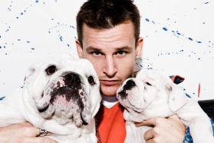](http://www.mtv.com/photos/rob-dyrdeks-fantasy-factory-rob-dyrdek/1602431/3500955/photo.jhtml)[http://upload.wikimedia.org/wikipedia/commons/thumb/9/99/Flag_of_the_Philippines.svg/125px-Flag_of_the_Philippines.svg.png](http://en.wikipedia.org/wiki/File:Flag_of_the_Philippines.svg)visit the Eifel Tower
* meet Ashton Kutcher, Christina Aguilera, or RobDyrdek
* stay best friends with Mary Kate McCarthy
* 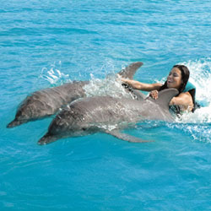[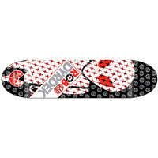](http://shop.ccs.com/product/model:113322/sku:61-18931/alien-workshop-dyrdek-soldier-x-band-deck/rob-dyrdek/black/white/?cm=skate.decks&supercat=Skate)tryout for a television show
* [](http://dance.blogs.fox.com/files/2011/01/SYTYCDflyer.jpg.jpg)learn how to ride a skateboard
* go on a cruise
* maintain a 4.0
* 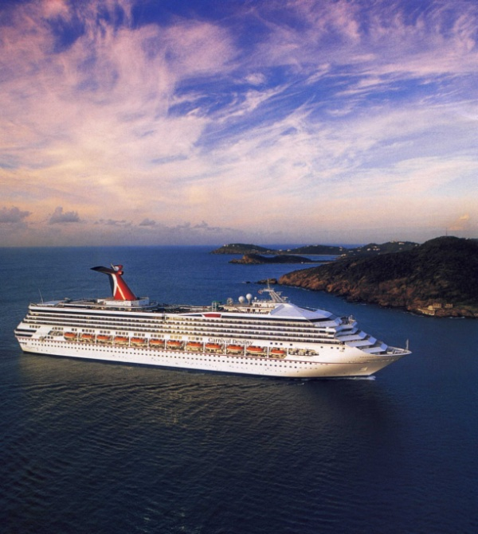learn how to speak Tagalog
* appear in a movie
* ride an elephant
* [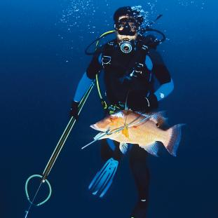](http://www.scubadiving.com/training/ask-expert/ask-expert-should-you-spearfish-scuba)[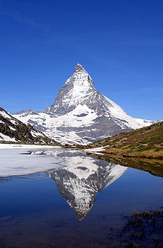](http://en.wikipedia.org/wiki/File:Matterhorn_Riffelsee_2005-06-11.jpg)climb a mountain
* do a switch leap
* go scuba diving
* swim with dolphins
* [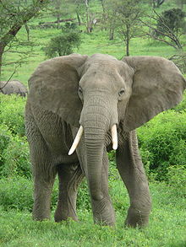](http://en.wikipedia.org/wiki/File:Elephant_near_ndutu.jpg)conquer a fear

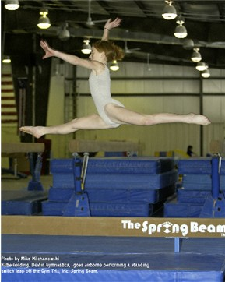

Angela VanDerHeyden